The Equalizer 6, 12 & 24 Hour Runs

Sponsored by The Equalizer Race Team and the Des Moines Park and Recreation Department
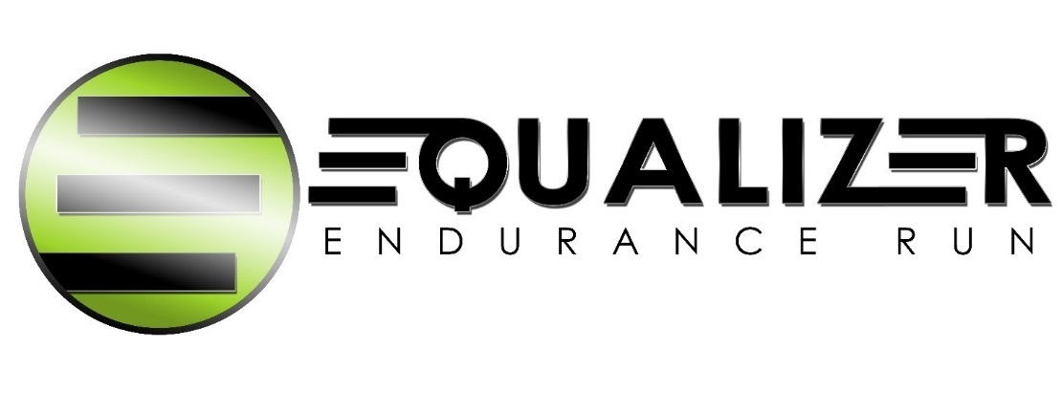

Saturday, October 31, 2020 - 8:00 AM

Gray’s Lake, Des Moines, Iowa

EVENT DESCRIPTION

This event is designed for three purposes. First, it will provide an opportunity for new and veteran runners to test themselves at an ultra distance. Second, performances will be scored using an age/sex “equalizer”, providing the possibility of an overall victory to anyone who is normally competitive in their age group. Equalizers are determined based on age and gender. Overall awards will be distributed based on the total of actual distance plus the appropriate equalizer. Third, everyone has fun, and we mean everyone!

EQUALIZERS

This event is designed so anyone competitive in his or her age/sex group could be the overall winner. The equalizers allow you to compete fairly with anyone you choose.

COURSE DESCRIPTION

A 1.905 mile essentially flat loop, lighted asphalt path, circling Gray's Lake with splendid views of downtown. USATF certified # IA02004-MF.

AID
There will be one aid station with water, pop, fruit, and cookies, as well as soup for the 24 hour; a runner should not rely solely on this for their aid. Indoor toilets will be available; showers will not. Room will be available for tents, though camping the Friday night before is not permitted.

ENTRIES ARE LIMITED

Entries will be limited to 100. Your entry will be confirmed by email. Please note, there is an online process listed on the Entry Form page if you would choose to enter in that manner. Otherwise, please complete this form and send it and the correct amount to the address listed below.

ENTRY FEE

Entry Fee is $60for the 6 hour, $70 for the 12 hour, and $85 for the 24 hour. Please make checks payable to Chris Zepp. Race shirts will be ordered around 10/14/2020. Entries are allowed after that date, but it is likely you will not get a race shirt and they are usually highly coveted. It is preferred you sign up early and give our volunteer staff time to prepare, but we understand ultra runners are a different category of runners and some make late decisions. We will accept race entries up until the time of the start of the race – 8am, October 31, 2020.

PRE-RACE DINNER

There will be no pre-race meal.

AWARDS

Race shirts will be given to all entrants who sign up on time and who are at the race. In the past, we required runners to at least complete a marathon to earn a shirt. We have eliminated that requirement…but c’mon…you are signing up for an ultra, you can do the marathon and then some.

Awards based on distance plus equalizer will be given to the first 10 places in each event. One award will be given for longest actual distance in each event. The award ceremony will immediately follow completion of the race.

EQUALIZERS FOR all distances (factor multiplied times actual distance; will be pro-rated to reflect exact age on race day.)

Age on |  |  |  | Age on |  |  |  | Age on
Race Day | Male | Female |  | Race Day | Male | Female |  | Race Day | Male | Female
0-34 | 1.000 | 1.111 |  | 51 | 1.205 | 1.370 |  | 68 | 1.515 | 1.786
35 | 1.010 | 1.124 |  | 52 | 1.220 | 1.389 |  | 69 | 1.538 | 1.818
36 | 1.020 | 1.136 |  | 53 | 1.235 | 1.408 |  | 70 | 1.563 | 1.852
37 | 1.031 | 1.149 |  | 54 | 1.250 | 1.429 |  | 71 | 1.587 | 1.887
38 | 1.042 | 1.163 |  | 55 | 1.266 | 1.449 |  | 72 | 1.613 | 1.923
39 | 1.053 | 1.176 |  | 56 | 1.282 | 1.471 |  | 73 | 1.639 | 1.961
40 | 1.064 | 1.190 |  | 57 | 1.299 | 1.493 |  | 74 | 1.667 | 2.000
41 | 1.075 | 1.205 |  | 58 | 1.316 | 1.515 |  | 75 | 1.695 | 2.041
42 | 1.087 | 1.220 |  | 59 | 1.333 | 1.538 |  | 76 | 1.724 | 2.083
43 | 1.099 | 1.235 |  | 60 | 1.351 | 1.563 |  | 77 | 1.754 | 2.128
44 | 1.111 | 1.250 |  | 61 | 1.370 | 1.587 |  | 78 | 1.786 | 2.174
45 | 1.124 | 1.266 |  | 62 | 1.389 | 1.613 |  | 79 | 1.818 | 2.222
46 | 1.136 | 1.282 |  | 63 | 1.408 | 1.639 |  | 80 | 1.850 | 2.270
47 | 1.149 | 1.299 |  | 64 | 1.429 | 1.667 |  | 81 | 1.882 | 2.316
48 | 1.163 | 1.316 |  | 65 | 1.449 | 1.695 |  | 82 | 1.914 | 2.358
49 | 1.176 | 1.333 |  | 66 | 1.471 | 1.724 |  | 83 | 1.947 | 2.404
50 | 1.190 | 1.351 |  | 67 | 1.493 | 1.754 |  | 84 | 1.980 | 2.451

PACKET PICKUP

We don’t have race sponsors, so there is no packet to pick up early. Please come to the main tent on race morning and get your bib number. We will pass out shirts at the end of each race.

CLIMATOLOGICAL DATA

Average High = Oct 64.3F; Average Low = Oct 42.7F; Record High = Oct 95F; Record Low = Oct 14F.
Average Wind Speed = Oct 10.3 mph.

QUESTIONS?

Contact Chris Zepp via e-mail at CLEOZEPP@GMAIL.COM or call Chris Zepp at 515-238-8559.

Name Date of Birth Sex
(Must be at least 18)

Address City State Zip_____________

Evening Phone Daytime Phone e-mail ___________________________

Race 6 hr___________ 12hr ______________ 24 hr___________

T-shirt size__________
# of Ultras Completed Best Performance # of dinner guests _______

My current plan is to attend dinner Friday evening Yes_______ No_______

Anticipated Distance for 6, 12 or 24 hours, in miles (without equalizer)________________________

ATHLETE'S RELEASE - Your entry will not be accepted without your signature

I the undersigned participant, intending to be legally bound, do hereby certify that I will be 18 years of age or older on 10/31/2020, I am physically fit, and have not been otherwise informed by a physician. I acknowledge that I am aware of all of the risks inherent in ultra running (training and competition) including possible permanent disability or death, and agree to assume all of those risks. I hereby waive any and all rights to claims for loss or damages arising out of participation in the Equalizer 6, 12 & 24 Hour Runs or any activities incident thereto against the organizers, Des Moines Parks and Recreation, sponsors, committees, or any individuals officiating, volunteering, or supervising such activities, as a condition of my participation.

Date Athlete's Signature _______________________________________________________________________

Mail checks made out to Chris Zepp and mail entries to Chris Zepp at 1116 16th St, West Des Moines, IA 50265.

